**Uttarakhand Environmental Analysis**

**Name: Amogh Javali**

**ID: NN/22/2355**

**Role: Data Analytics**

**Introduction**

Uttarakhand, a state in northern India, is known for its rich biodiversity, extensive forest cover, and fragile Himalayan ecosystem. However, rapid urbanization, industrialization, and population growth have led to environmental degradation. This report analyses Uttarakhand’s environmental status across key factors and presents a comparative study of its conditions over time.

**Index**

* Introduction
* Index
* Geological and Topographical Factors
* Climatic Conditions
* Forests and Biodiversity
* Water Resources
* Land Use and Urbanization
* Disaster Risk and Management
* Pollution and Environmental Degradation
* Socio-Economic & Policy Aspects
* Daily Activities Log
* Conclusion & Recommendations
* Bibliography

**Geological and Topographical Factors**

**Uttarakhand is characterized by diverse geological features, including:**

* The Himalayan range, with fragile slopes prone to landslides.
* The Terai and Bhabhar regions with fertile plains suitable for agriculture.
* Numerous glaciers, including Gangotri and Pindari, that feed major rivers.

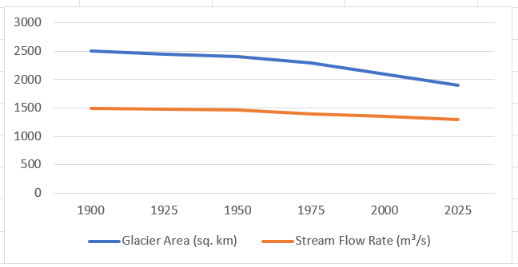

**Key Changes Over Time:**

* Increased deforestation leading to higher risks of landslides.
* Expansion of infrastructure projects, affecting terrain stability.
* Greater focus on sustainable development policies.

**Climatic Conditions**

**Uttarakhand experiences varied climate zones:**

* Alpine (High-altitude regions).
* Temperate (Mid- Mountain zones).
* Subtropical (Foothills and plains).

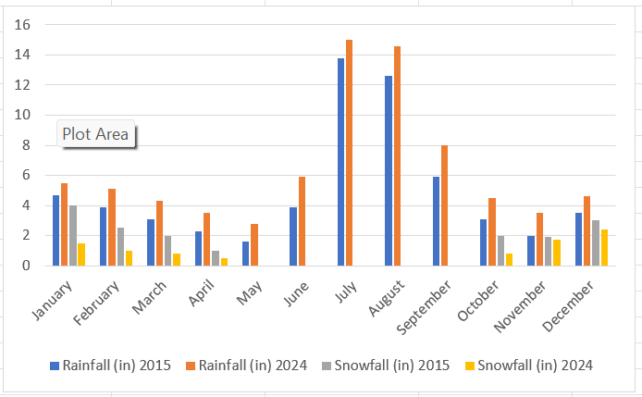

**Key Changes Over Time:**

* Rising temperatures due to climate change.
* Unpredictable monsoons increasing flood risks.
* Increase in forest fires and reduced snowfall in glacier zones**.**

**Forests and Biodiversity**

Forest coverage in Uttarakhand has historically been high, contributing to rich biodiversity.

**Present Conditions:**

* Forests cover 61% of the state’s area.
* Important wildlife species include tigers, leopards, elephants, and musk deer.
* Conservation efforts are ongoing, but urban expansion threatens wildlife corridors.

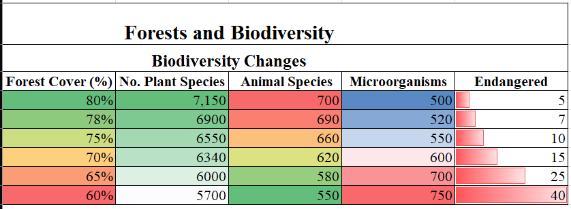

**Key Changes Over Time:**

* Increase in protected areas and afforestation efforts.
* Wildlife migration due to habitat destruction.
* Stricter laws against illegal deforestation.

**Water Resources**

**Uttarakhand is home to several major rivers and water bodies:**

* Ganga, Yamuna, Alaknanda, Bhagirathi, Kali, and Tons.
* Glacial meltwater and monsoonal rains are primary sources.

**Challenges and Improvements**

* Increased water pollution due to urban waste.
* Rising demand leading to depletion of groundwater.
* Improved water treatment and conservation policies.

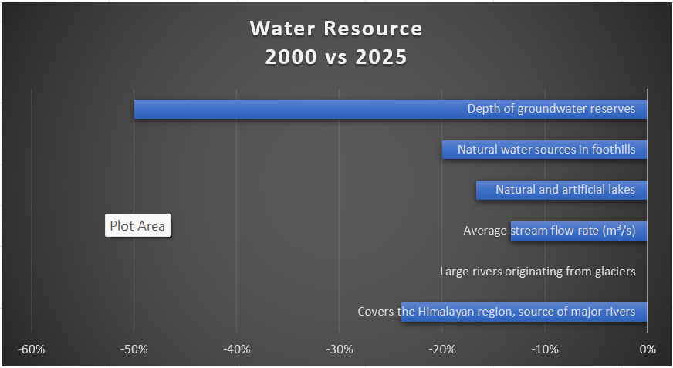

**Land Use and Urbanization**

Urbanization in Uttarakhand has been growing, particularly in cities like Dehradun, Haridwar, Rudrapur, and Roorkee.

**Current Urbanization Rate**

* 30.2% urbanization rate, close to the national average of 31.2%.
* 4% annual urban growth rate, higher than the rural growth rate of 1.2%.

**Major Concerns**

* Encroachment on fragile mountain ecosystems.
* Unplanned expansion leading to environmental stress.
* Better implementation of land-use policies.

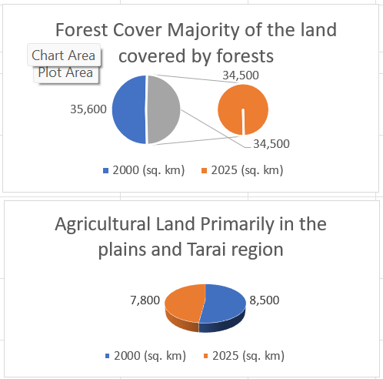

**Disaster Risk and Management**

The Uttarakhand State Disaster Management Authority **(USDMA)** plays a key role in disaster response.

**Key Risk Factors**

* Unscientific construction.
* Illegal mining.
* Construction of hydropower projects and tunnels.

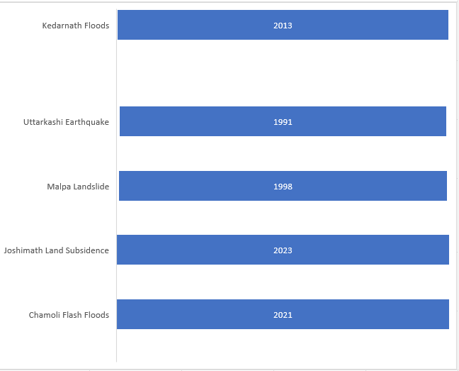

**Improvements Over Time**

* Strengthened policies and emergency response.
* The U-PREPARE project, supported by the World Bank, enhances resilience.
* Public awareness programs have increased preparedness levels.

**Pollution and Environmental Degradation**

Uttarakhand faces serious environmental concerns, including air, water, and land pollution.

**Air Pollution**

* Vehicular emissions and industrialization contribute to poor air quality.
* The current AQI (2025) is 71, an improvement over previous years due to stricter emissions control.

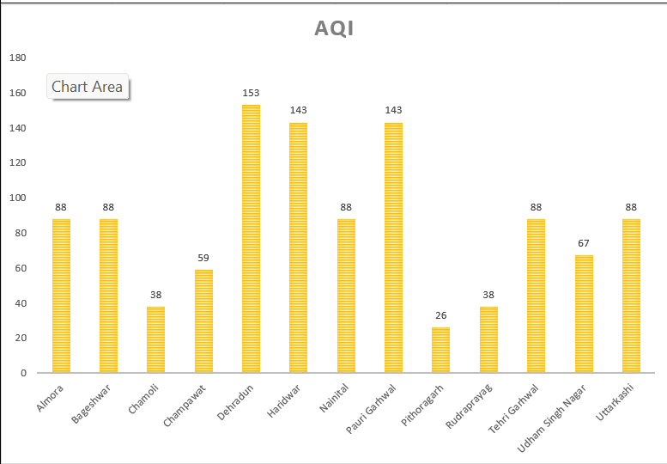

**Water Pollution**

* Industrial waste and tourism-driven pollution affect rivers.
* Water Quality Index (WQI) for major rivers has fluctuated, with efforts improving treatment facilities.

**Key Changes Over Time**

* Air quality has improved due to emission control measures.
* Water treatment infrastructure has expanded.
* Solid waste management has seen moderate progress.

**Socio-Economic & Policy Aspects**

Uttarakhand’s economy relies on tourism, agriculture, and hydropower.

**Tourism Sector**

* Increased tourist inflow due to improved infrastructure.
* More eco-tourism initiatives.
* Overcrowding remains a challenge in pilgrimage sites.

**Agriculture Sector**

* Growth in organic farming.
* Decline in traditional farming due to migration.
* Government support for farmers through subsidy programs.

**Education Sector**

* Increased literacy rate.
* Expansion of higher education institutions.
* Digital learning initiatives launched post-2020.

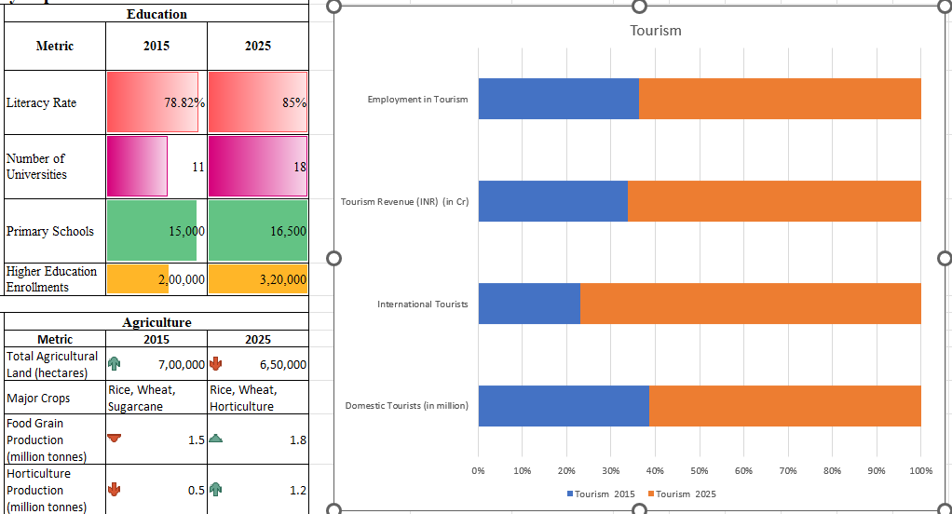

**Daily Activities Log**

* **Day1:** Data collection on AQI, WQI, and forest cover.
* **Day2:** Analysis of urbanization trends.
* **Day3:** Research on disaster management strategies.
* **Day4:** Compilation of pollution-related data.
* **Day5:** Review of socio-economic policies.
* **Day6:** Drafting the final report.
* **Day7:** Proofreading and report submission.

**Conclusion & Recommendations**

**Findings**

* Uttarakhand has seen significant changes over time, with improvements in pollution control, disaster preparedness, and economic development.
* However, challenges remain, including unplanned urbanization and environmental degradation.

**Recommendations**

* Stronger implementation of land-use policies.
* Enhanced disaster management strategies.
* Promotion of eco-friendly tourism and sustainable agriculture.

**Bibliography**

* Air_quality.com
* PHD Chamber of Commerce and Industry website
* CRL Diagnostics website
* Indiastat website
* PREPdata website
* ChatGPT
* Google AI
* Government of Uttarakhand portals
* World Bank reports on disaster preparedness
* Reports from Uttarakhand Pollution Control Board